1. Default exchange is not a type.
2. It can’t be created nor deleted.
3. It has a special role.
4. 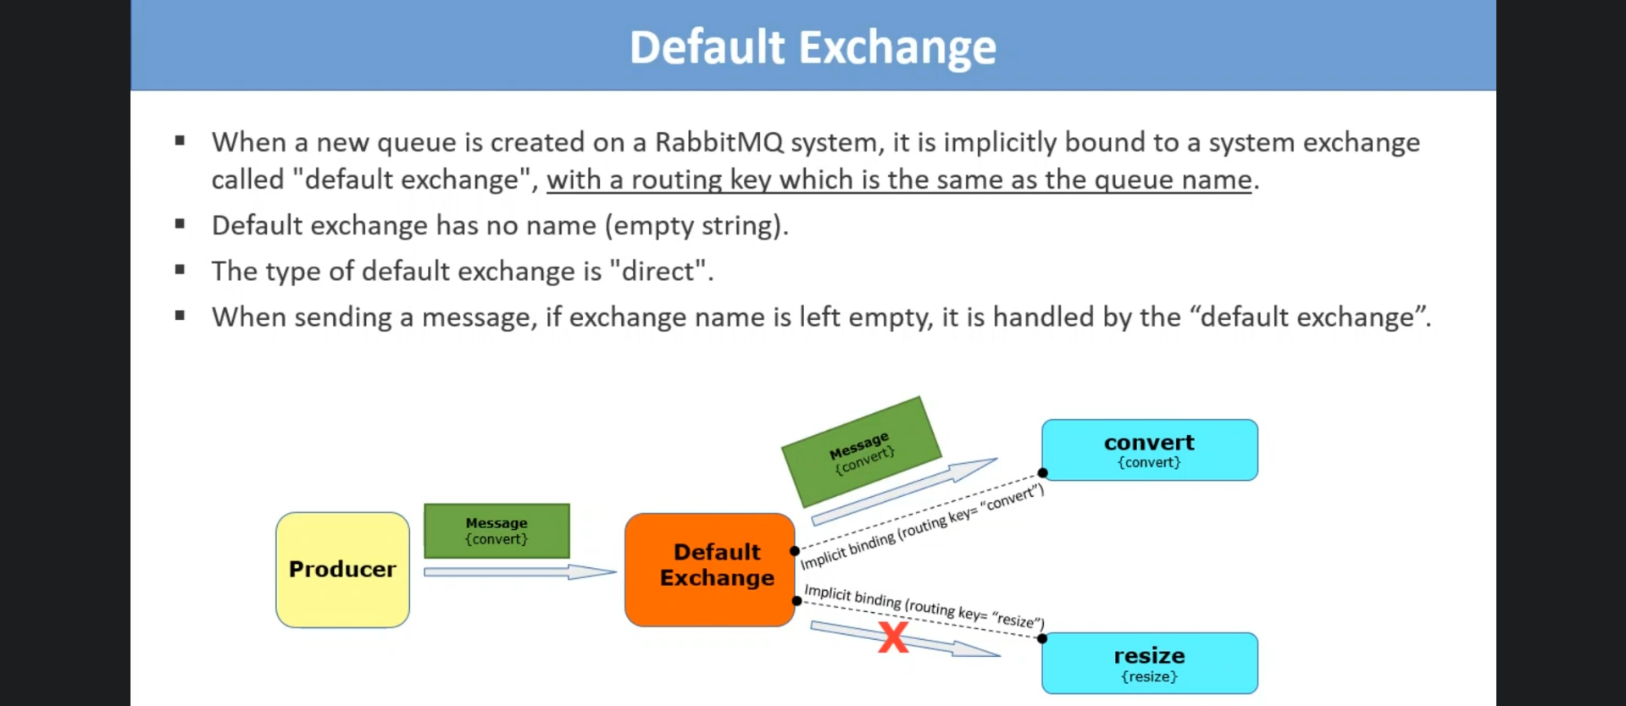
5. Default Exchange:
   1. This is created automatically.
   2. Its exchange type is “**Direct**” which means routing key in msg will be matched with routing key of queue, if they match, the msg will be routed to that queue.
   3. If no matching queue, the msg is discarded.
   4. 2nd this default exchange will route msg to only those queues which are not bound to any exchange so they are by default bound to default exchange and their binding routing key will be the queue name itself.